|  |  |  |  |  |  |
| --- | --- | --- | --- | --- | --- |
| Date | 12-Dec-22 | | | Tester Name | Mayuri Patel |
| Environment | Penfax - Test | | | Login used |  |
| Operating System | Select OS | Version: | Update: | | |
| Software Used | Select Software | Version: | Update: | | |
| Select Software | Version: | Update: | | |
| Release version | 22.4.1 | | | | |
| Title |  | | | | |
| Test Type | Regression | | | | |
| Test Scenario | MLA Address for SRP Statement Extract | | | | |
|  |  | | | | |
| Expected Results |  | | | | |
| Pass/Fail | Pass | | | JIRA# | N/A |

Describe your steps with screenshots:

Go to Batch processes

Enter Batch Process Type to MLA Address Extract for SRP Statements and Search

Select the recent report

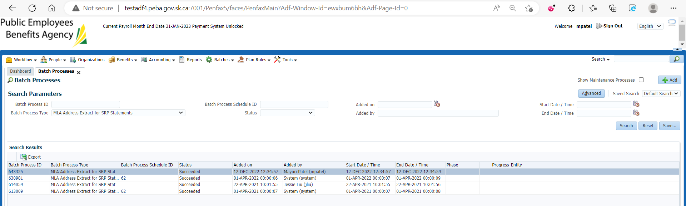

Download the report from under the files tab

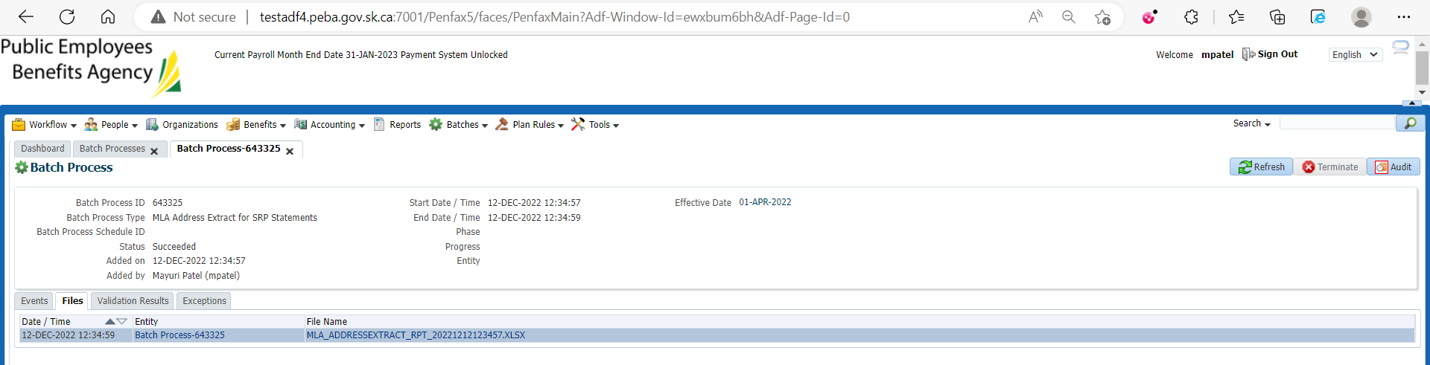

Open that report

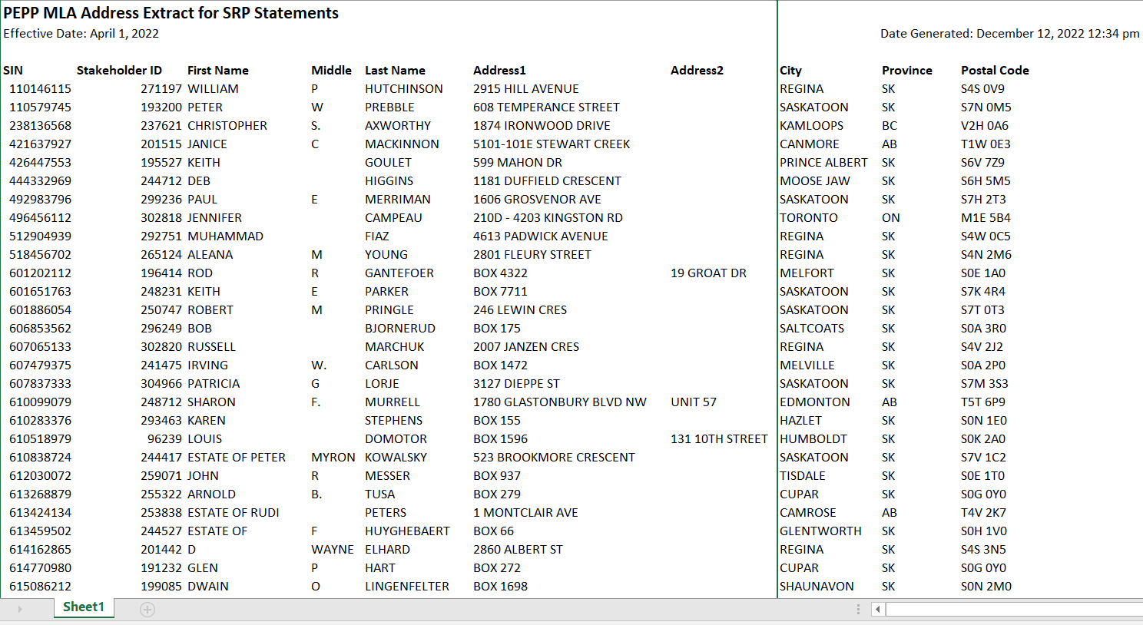

Verify the values

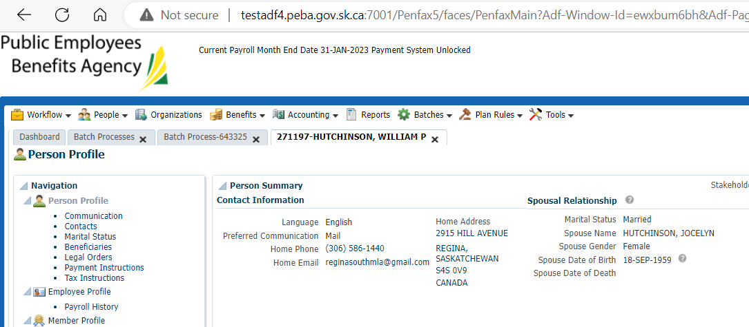

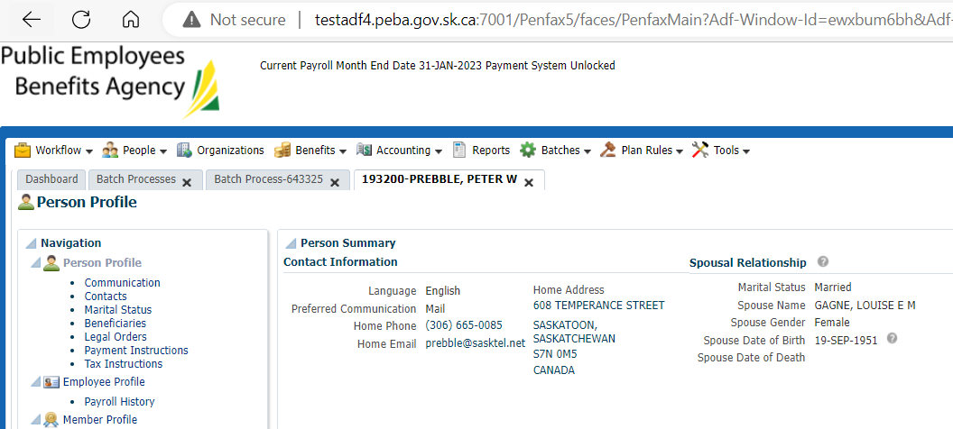

MLA Address for SRP Statement Extract is saved at: H:\Quality Assurance\Prod Apps\Testing Management\Regression Testing\Nov 2022 - PENFAX 22.4.1 Release\PEPP\Test Results\E28 Extracts